**MOBILE COMPTUING**

**Name : Umer Khan**

**Std Id : BSEF18A020**

Git Hub account **: umerk10**

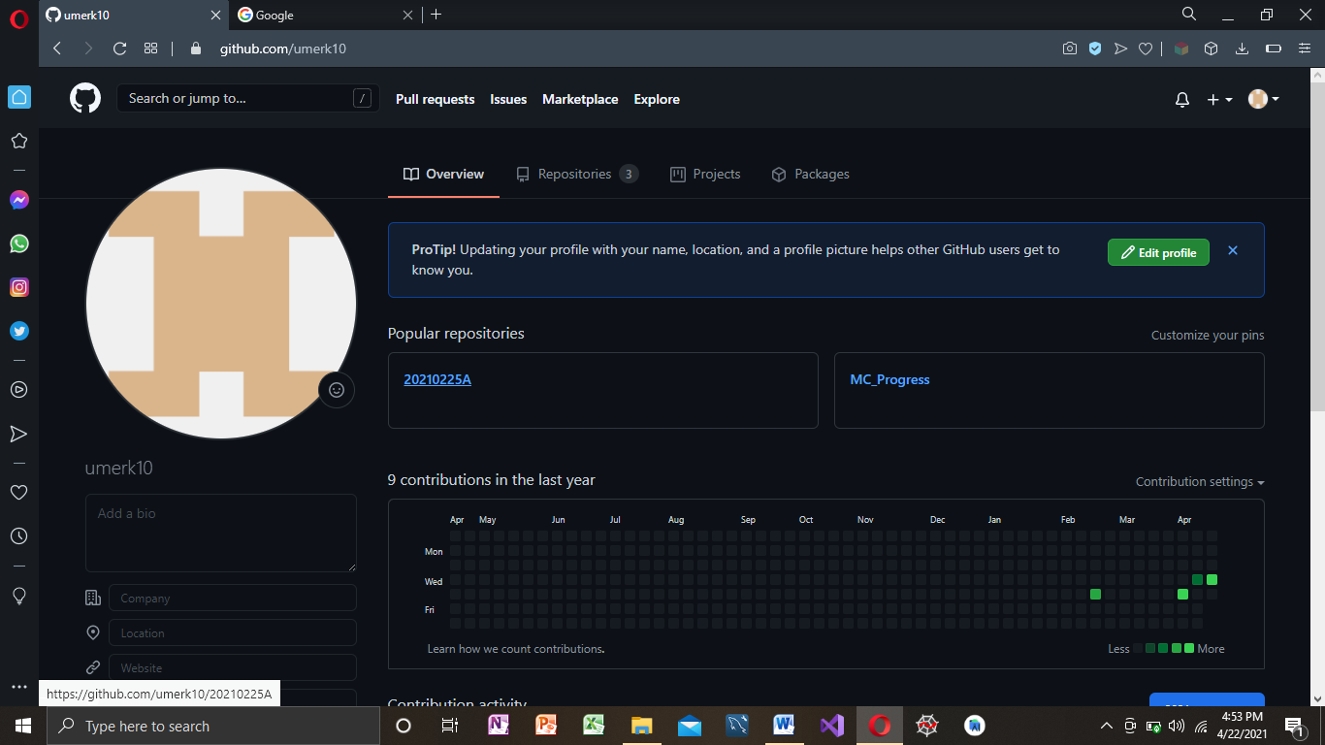

Repsitory Making : https://github.com/umerk10/20210225A.git

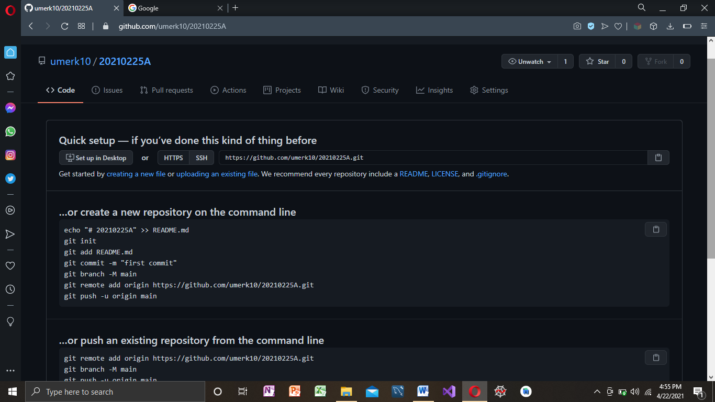

Git clone

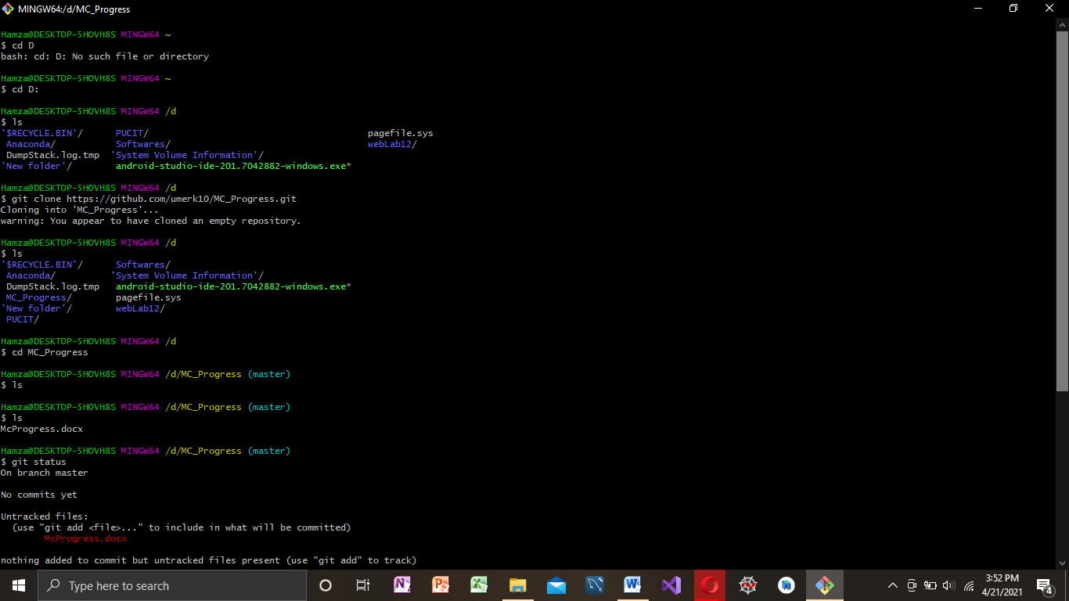

Git Add,Commit,Push,Status:

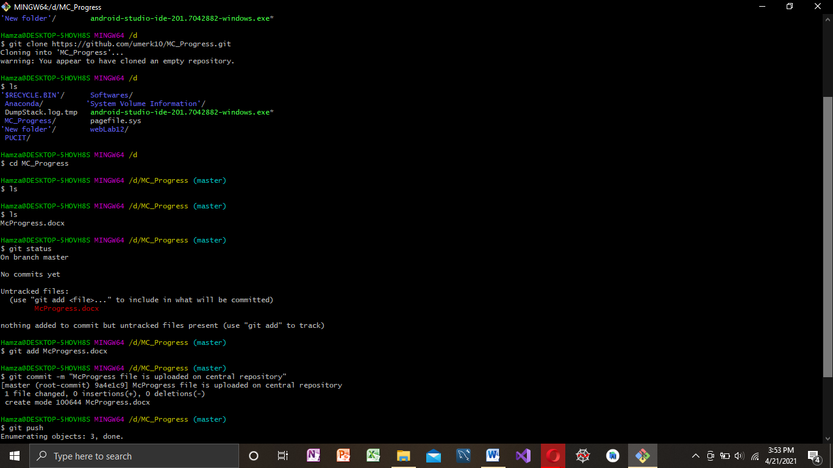

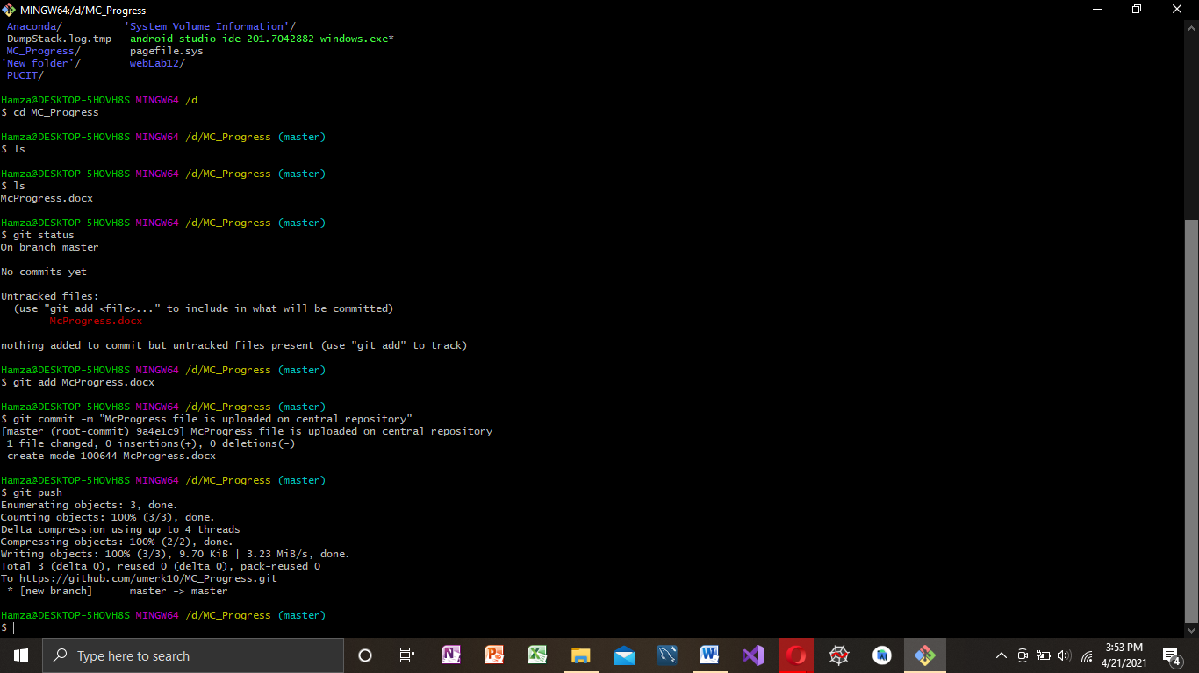

Andriod Studio:

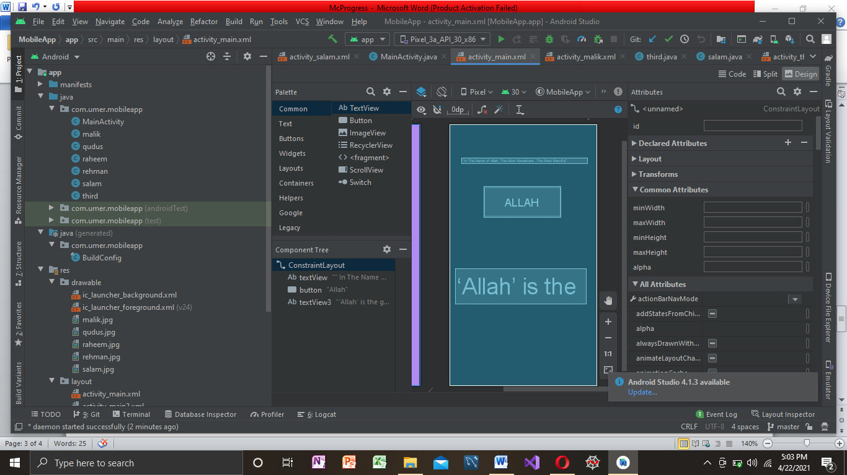

Basic Mobile Application:

 Video of basic app